HNDIT 2062 – Group Project
College Event Management System

No. | Index Number | Name
1 | NAW/IT/2324/F/0031 | Sangeetha
2 | NAW/IT/2324/F/0049 | J. V. A. Kumarasiri
3 | NAW/IT/2324/F/0206 | Krishanthini
4 | NAW/IT/2324/F/0030 | A. R. F. Rimza
5 | NAW/IT/2324/F/0017 | F. Mysara

Department of Information Technology
Advanced Technological Institute - Nawalapitiya
Sri Lanka Institute of Advanced Technological Education
2023(2024)
Declaration

We declare that this thesis is our own work and has not been submitted in any form for another degree or diploma at any university or other institution of tertiary education. Information derived from the published or unpublished work of others has been acknowledged in the text and a list of references is given.

Name of student (s):
Signature of student (s):

Date:

Supervised by: Signature of supervisor(s):

Date:

I

Acknowledgement

We would like to express our sincere gratitude to our college lecturer, Mrs. Dhilini,, and the Head of the IT Department, Mr. Laxman, for their continuous guidance and support throughout the development of our college event management system. Their valuable feedback and encouragement have greatly contributed to the success of this project.

We are also thankful to our college, SLIATE, for providing us with the opportunity and resources to undertake this project. The experience has helped us enhance our practical skills in web development, interface design, and collaborative problem solving.

Our heartfelt thanks go to our friends and classmates for their support, motivation, and helpful discussions.

II

Abstract

This project focuses on developing a college event management system to address the inefficiency of traditional methods like physical announcements and social media for informing students about upcoming events. The system offers a centralized digital platform where students can view events, book tickets, check notifications, and access galleries of past events. Admins can manage event details, media, student records, and payments through a dedicated panel.

The system uses HTML, CSS, and JavaScript to create an interactive interface. Evaluation of the system demonstrated that it improved communication and engagement among students while providing a streamlined process for event management. In conclusion, the system effectively solves the problem of inefficient event information dissemination within a college, offering a user-friendly and centralized solution.

III
Contents
Page

Chapter 1: Introduction 1
1.1 Background & Motivation

1.2 Aim and Objectives
1.3 Solution Overview
1.4 Report Structure

Chapter 2: Proposed Solution 2
2.1 Functional Requirements
2.2 Non-Functional Requirements
2.3 Chosen front-end technologies
2.4 Solution concerning users, inputs, outputs, processes, and
technologies

Chapter 3: Analysis and Design 3
3.1 User Interface Design
3.2 System Architecture
3.3 Diagrams

Chapter 4: Implementation 4
4.1 Front-End Development Process
4.2 Technologies Used
4.3 UI components
4.4 Flowchart
4.5 Sample Code Snippets
4.6 Testing

Chapter 5: User Manual 8
5.1 A Step-By-Step Guide On Using The Front-End System

Chapter 6: Conclusion and Further Work 8

References 9

IV
List of Figures

Page

Figure 4.1 – Home page 6
Figure 4.2 – About page 6
Figure 4.3 – Series page 6
Figure 4.4 – Non-series page 7
Figure 4.5 – Recommendation page 7

V

Chapter 1
Introduction

Background & Motivation
In many colleges, event announcements are made through posters, notice boards, or scattered social media posts. These methods are often inefficient, fail to reach all students promptly, and lack a centralized place for students to view details, book tickets, or revisit past event highlights. The motivation behind this project is to solve this communication gap by developing a centralized Event Management System tailored for a college environment.
This system helps students stay informed about upcoming events, explore media from previous ones, and allows admins to manage event-related content with ease. By bringing together all event-related activities into a single platform, this project aims to enhance student engagement and reduce manual effort for college staff.

1.2 Aim and Objectives
The aim of this project is to develop a web-based Event Management System (EMS) for a college that will provide a centralized platform for managing and communicating about events. The system will facilitate seamless interaction between students and administrators by allowing students to view, register for events, and access multimedia content, while providing administrators with a tool for management.

The main objectives of this project include:
- To develop a user-friendly system for students to view, register, and interact with event content, and to enable administrators to manage event-related data, media, and payment records easily.
- To replace traditional communication methods with a more effective, centralized platform for managing and disseminating event information.
- To provide functionalities like event booking, viewing past events' media, and managing user data.

1
1.3 Solution overview

Users:
- General Public: Can view event details and access media without registration.
- Students: Can view, register, and book tickets.
- Administrators: Can manage events, media, and user registrations.
Input:
- Students: Event registration, profile updates.
- Admins: Event creation, media uploads, and student management.

Output:
- Students: Booking confirmation.
- Admins: Dashboards for managing events, media, and users.

Process:
- The system allows public users to browse events, while students can register for events. Admins can manage the system’s content, including event and media data.

Technology:
- Frontend: HTML, CSS, and JavaScript.
- Storage: LocalStorage for storing user data temporarily (no backend).

1.4 Report Structure
Chapter 1 – Introduction: Introduces the project, background, and objectives.
Chapter 2 Proposed Solution: Details the functional and non-functional requirements, technologies used, user roles, inputs, outputs, and front-end implementation
Chapter 3 – Analysis and Design: Covers UI design and system layout using wireframes, use case diagrams, and (if applicable) class diagrams to show user interactions and interface structure.

2
Chapter 4 – Implementation: Explains how HTML, CSS, and JavaScript were used to build the system. Includes development process, sample code, and UI components used.
Chapter 5 – User Manual: Provides step-by-step guidance with screenshots on how to use the system’s features, including navigation and form interactions.
Chapter 6 – User Manual: Provides step-by-step guidance with screenshots on how to use the system’s features, including navigation and form interactions.
Chapter 7 – References: Contains the list of all cited materials used in the report, following the standard citation format.

3
Chapter 2

Proposed Solution

2.1 Functional Requirements
- Students can log in to view notifications, event details, profile info, and book tickets.
- Admins can manage events, media, students, payments, and notifications through a secured panel.
- Public users can browse events and gallery pages without logging in.

2.2 Non-Functional Requirements
- The UI must be user-friendly and visually consistent.

- Pages should load quickly with clear navigation.

- The system should function smoothly on modern desktop browsers.

2.3 Chosen front-end technologies
- HTML structures the web pages, organizing content like event details, student profiles, media, and payment records in a readable and accessible format.

- CSS ensures a consistent and visually appealing layout, helping users easily navigate through different sections such as dashboards, notifications, and galleries.

- JavaScript adds interactivity, allowing features like showing/hiding content, form validation, data storage with localStorage.

4
2.4 Solution concerning users, inputs, outputs, processes, and technologies
Users:
The system serves three main user groups: general visitors (public), students, and administrators.
- General users can view event details and galleries.
- Students can log in to view event notifications, book tickets, and view media.
- Admins can log in to manage events, media, students, payments, and other admin users.

Inputs:
Inputs include form data such as login credentials, event details (title, date, description), media uploads (image/video names), and payment info like name, student ID, and amount.

Outputs:
Outputs are the dynamically displayed event lists, user notifications, booking confirmations, media galleries, and payment receipts—all shown in the browser.

Processes:
Key processes include user login validation, adding/viewing event or media content, booking tickets, managing student and admin data, and recording/viewing payments. Data is temporarily stored using JavaScript's localStorage

5
Chapter 3
Analysis and Design

3.1 User Interface Design
The user interface was designed to be clean, intuitive, and easy to navigate. The layout uses consistent styling and positioning for elements like navigation bars, buttons, and content sections. Each page follows a structured layout with headings, action buttons, and responsive UI components for a smooth user experience.

- The Home Page introduces the system.
- The Event Page lists upcoming events with detailed views.
- The Gallery Page shows images and videos of past events.
- The Student Panel includes dashboard, notifications, and profile.
- The Admin Panel allows managing events, media, students, admins, and viewing payment records.

3.2 System Architecture
The system follows a simple static front-end architecture. HTML provides structure, CSS handles design, and JavaScript manages interactivity and local data storage using localStorage. There is no backend or database; all functionality is handled on the client side.

6
3.3 Diagrams
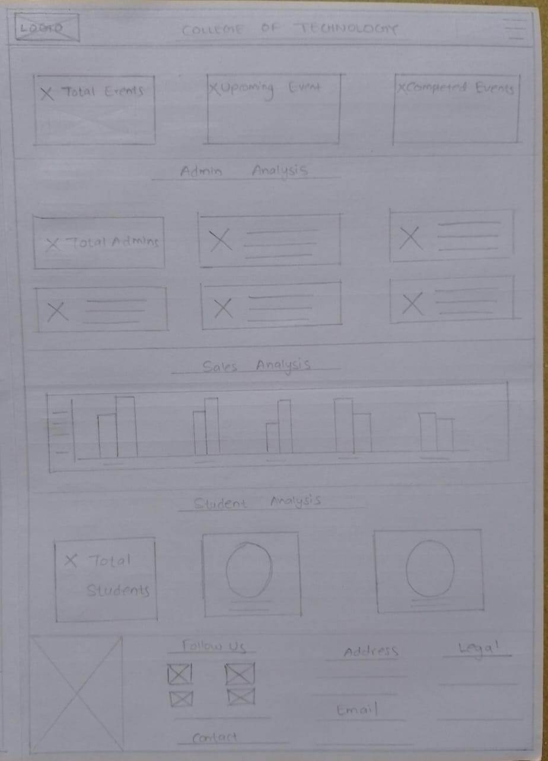
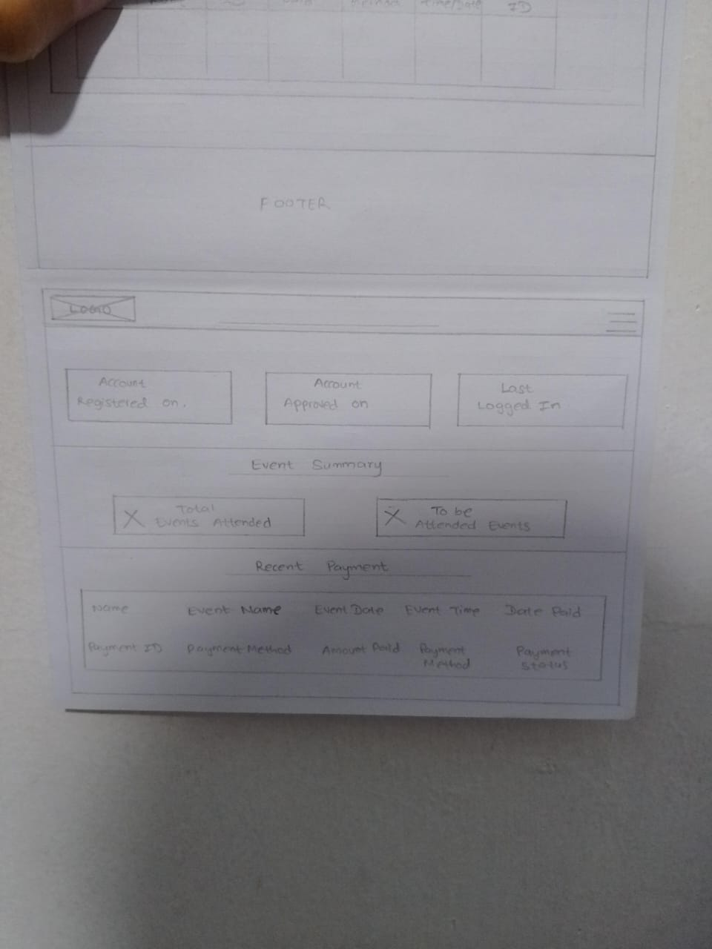
Figure 3.1: Wireframes
Figure 3.1.2 – Student Dashboard

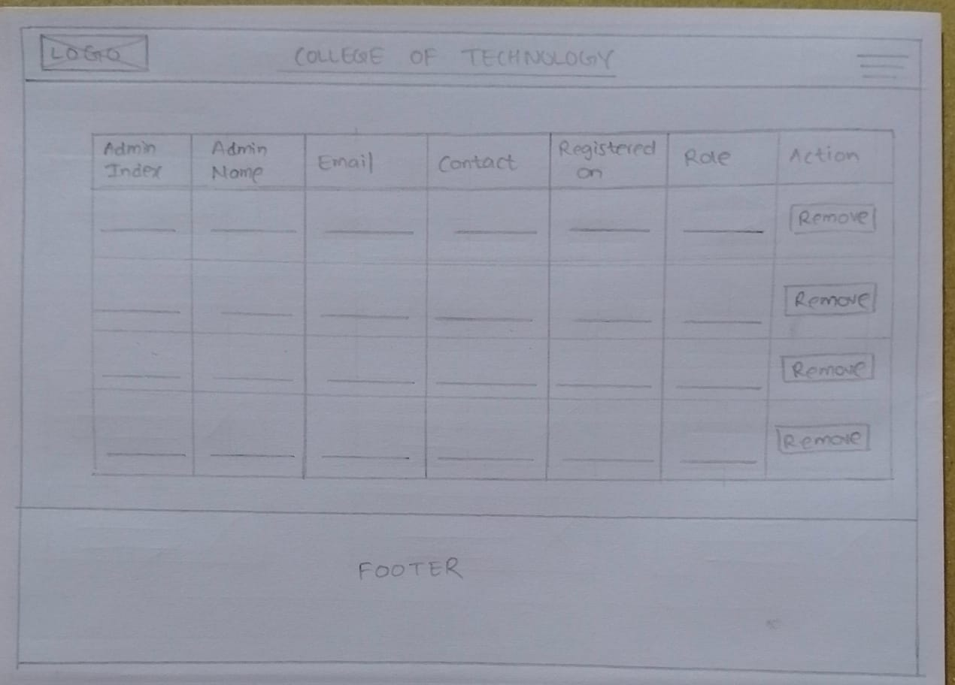
Figure 3.1.1 – Admin Dashboard

Figure 3.1.3 –
Admin Panel (manage admins section)

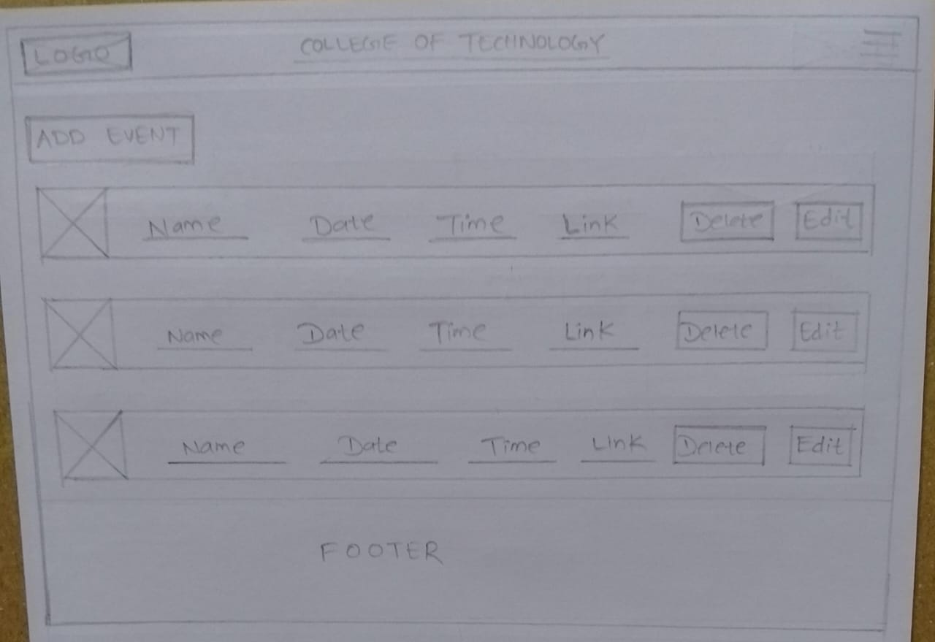

Figure 3.1.4 –
Admin Panel
(Manage events
section)

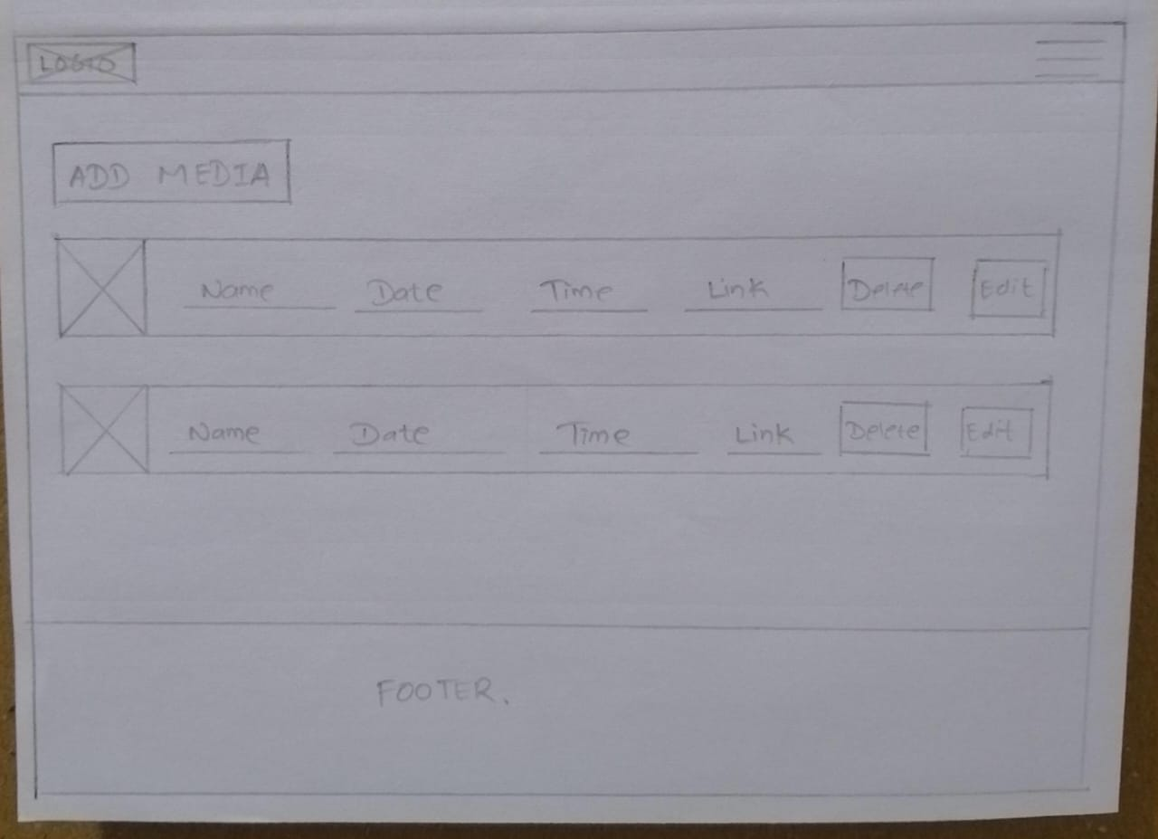

Figure 3.1.5 –
Admin Panel
(Manage media
section)

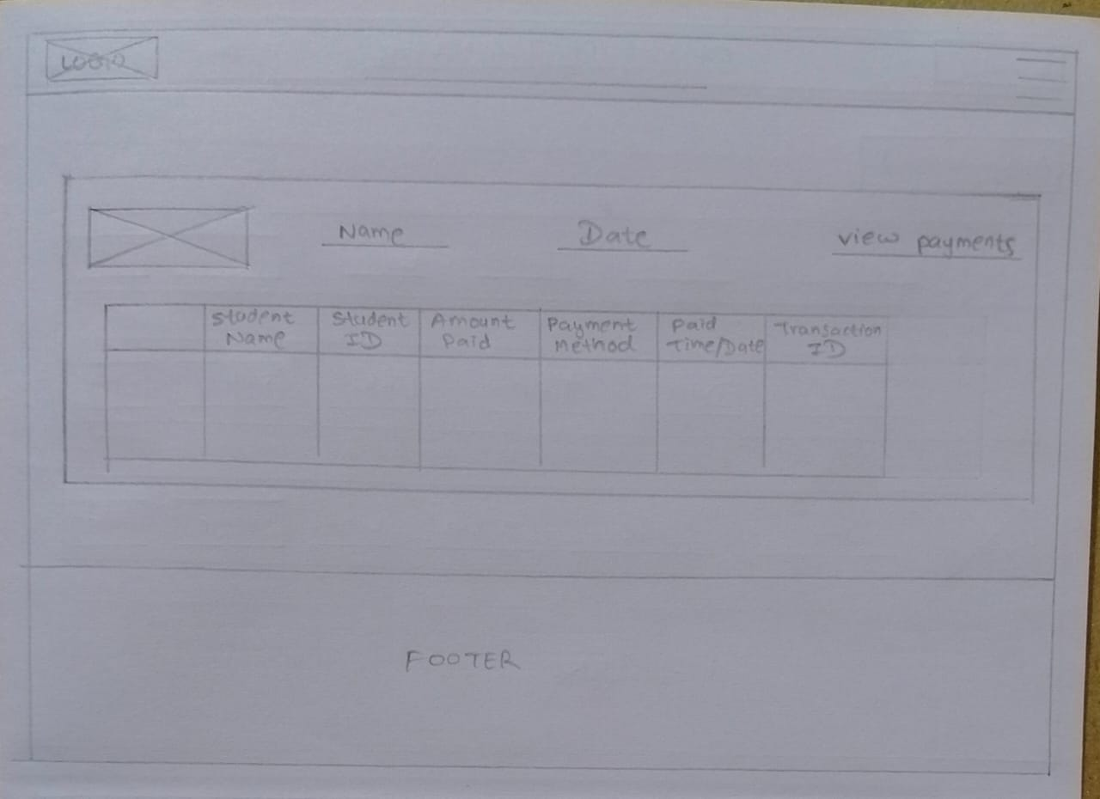

Figure 3.1.6 –
Admin Panel
(payments section)

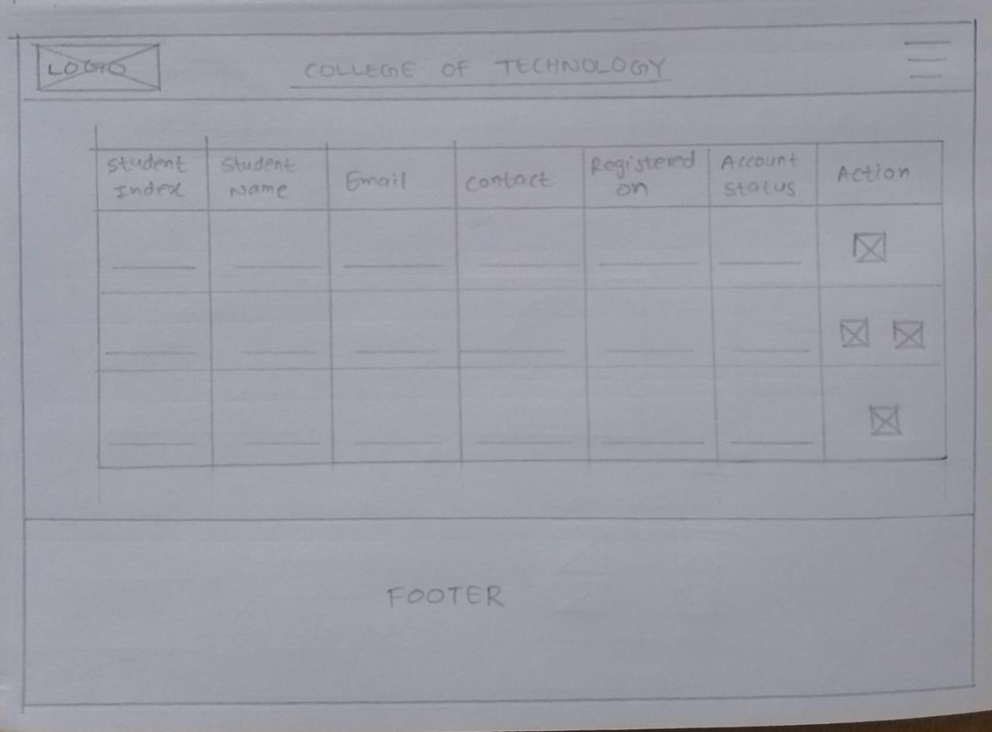

Figure 3.1.7 –
Admin Panel
(manage
students section)

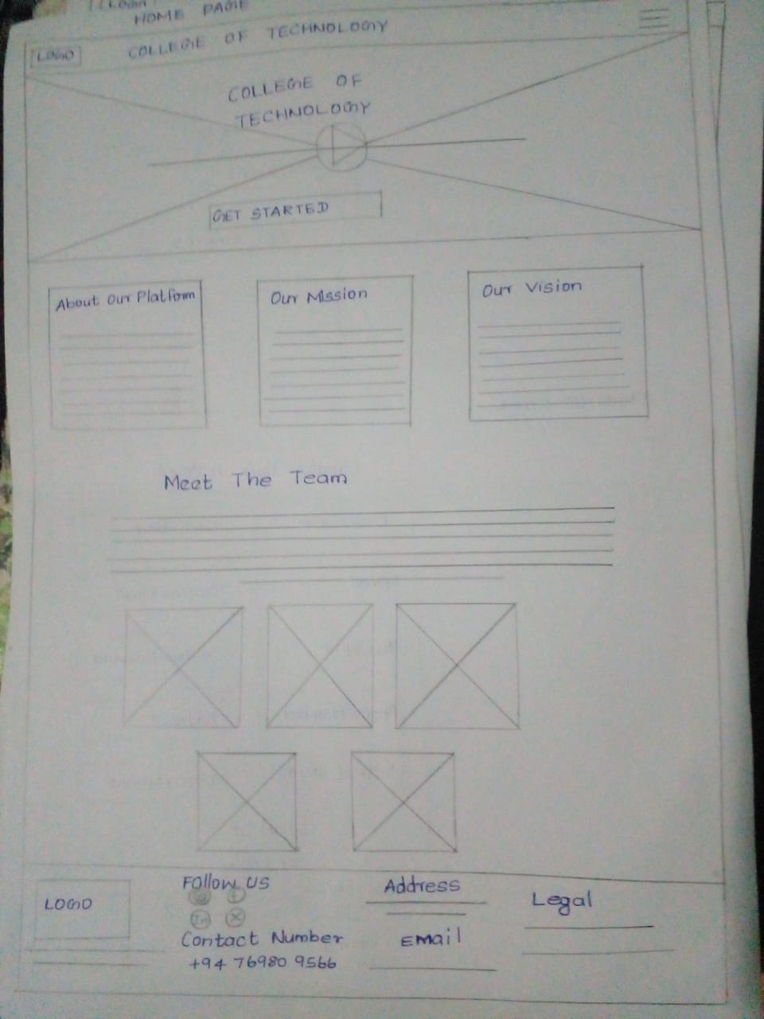

Figure 3.1.8 –
Home Page

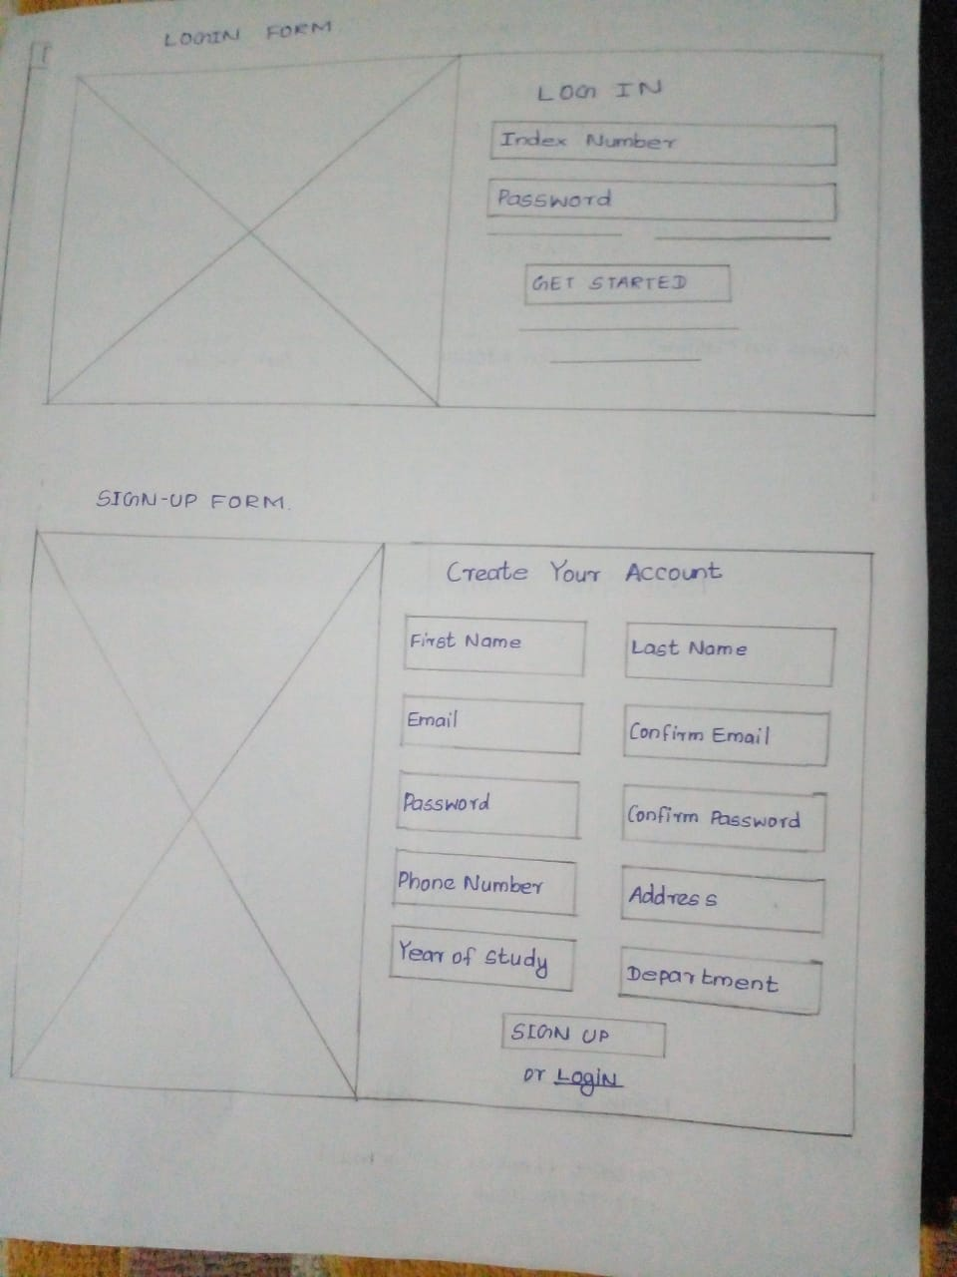
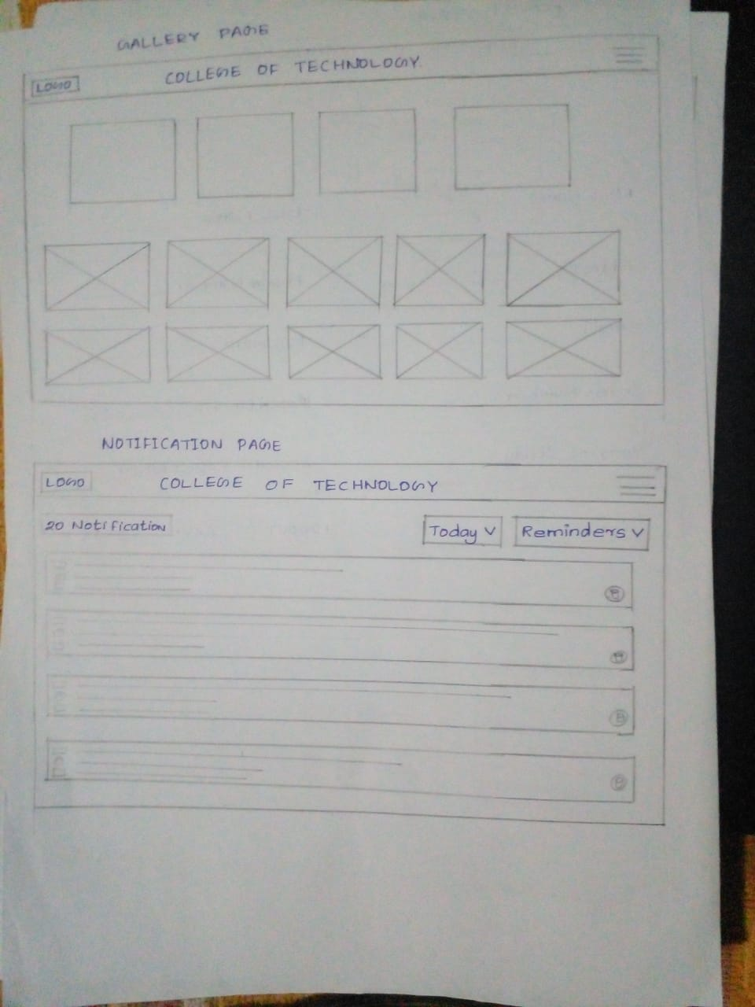
Figure 3.1.9 – Gallery Page Figure 3.1.10 – Login, Signup
And Notification Page

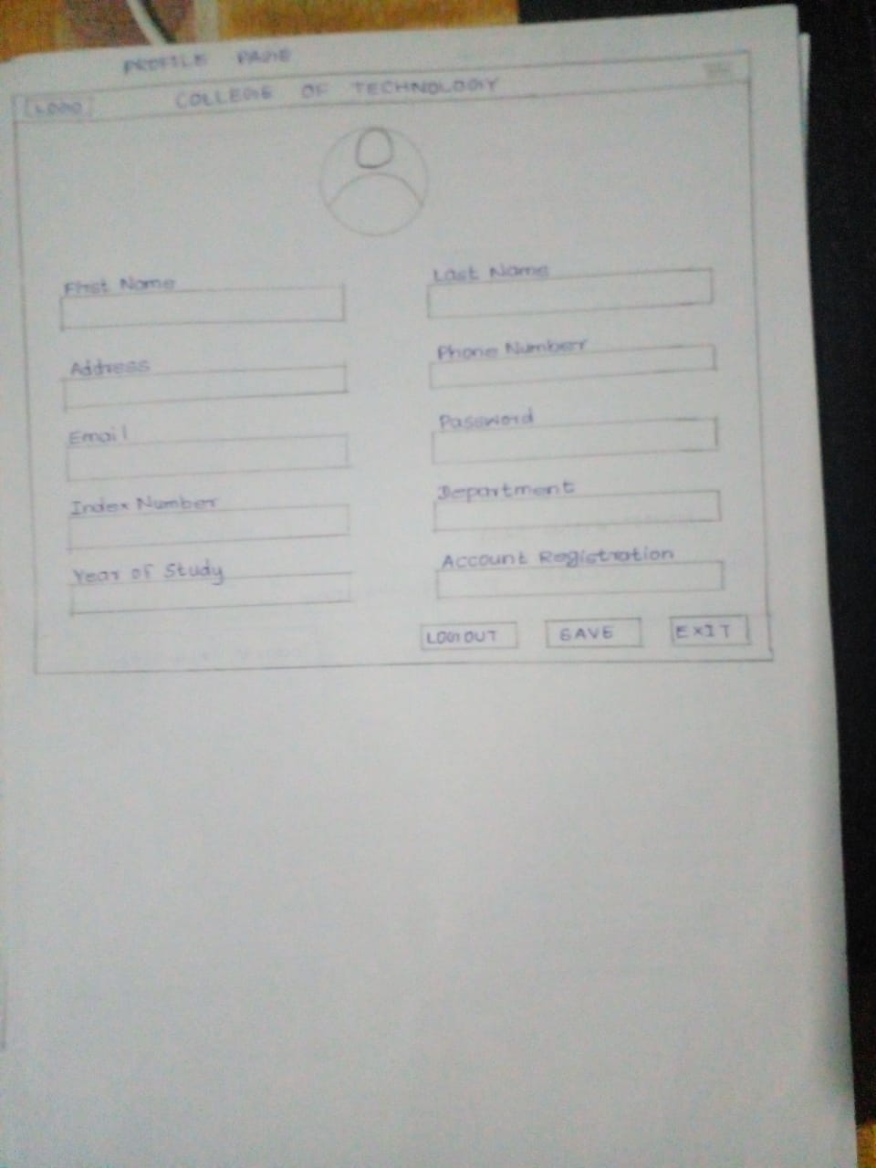

Figure 3.1.11 –
Profile Page

Figure 3.1.12 –
Events Page

Figure 3.2: Use Case Diagram

7

Chapter 4
Implementation

4.1 Front-End Development Process
The project was developed using basic front-end technologies without any external frameworks or libraries. All pages were coded manually using HTML for structure, CSS for styling, and JavaScript for interactivity. The development was done in Visual Studio Code.

4.2 Technologies Used
- HTML: Used to structure all content on the pages, including forms, buttons, sections, and layout containers.
- CSS: Used for visual styling, including colors, spacing, layout, hover effects, and media queries for basic responsiveness.
- JavaScript: Handles interactivity such as showing/hiding sections, form validation, dynamic content updates, and storing data in localStorage.

4.3 UI Components
- Home Page: Displays system introduction.
- Event Page: Lists events with booking options.
- Gallery: Shows past event images and videos.
- Student Panel: Allows login, shows dashboard, notifications, and profile information.
- Admin Panel: Manages events/media/students/admins and views payments.

8
4.4 Flowchart

4.5 Sample Code Snippet
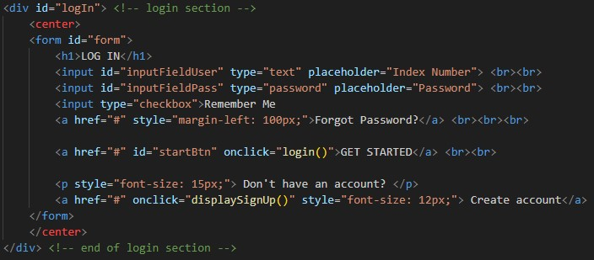
(Figure 1.1 Login Module)

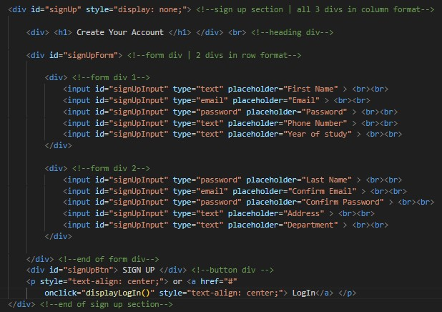
(Figure 1.1 Login Module)

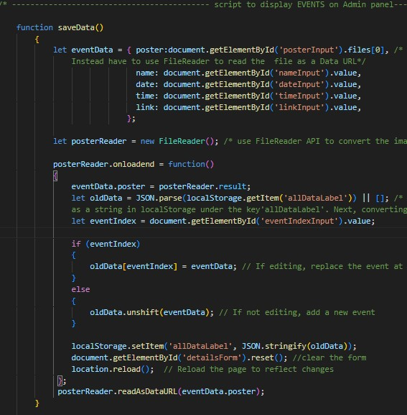
(Figure 1.1 Event Display Module)
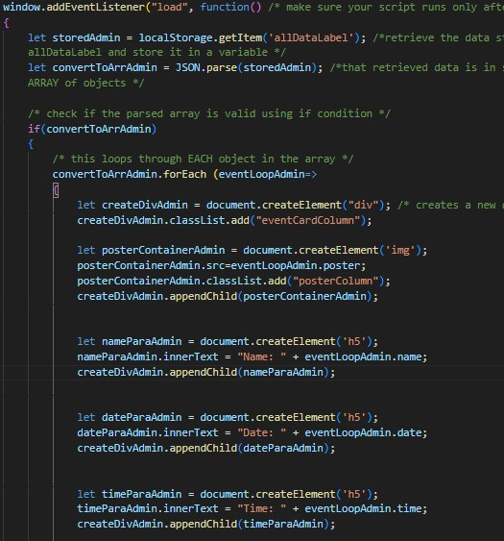
(Figure 1.1 Event Display Module)

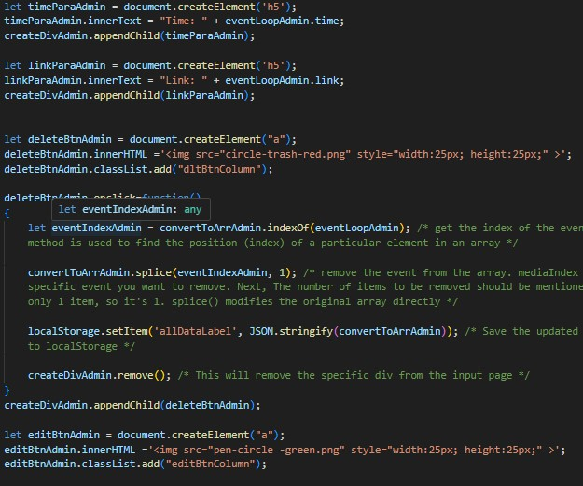
(Figure 1.1 Event Display on Admin Panel Module)
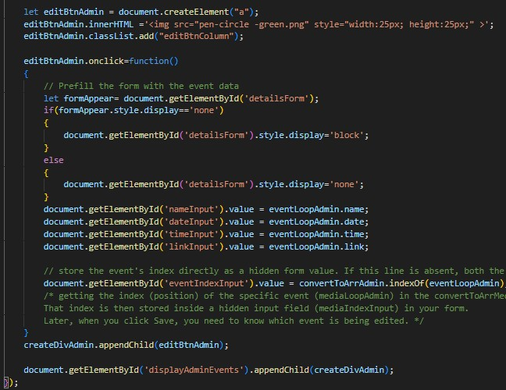
(Figure 1.1 Event Display on Admin Panel Module)
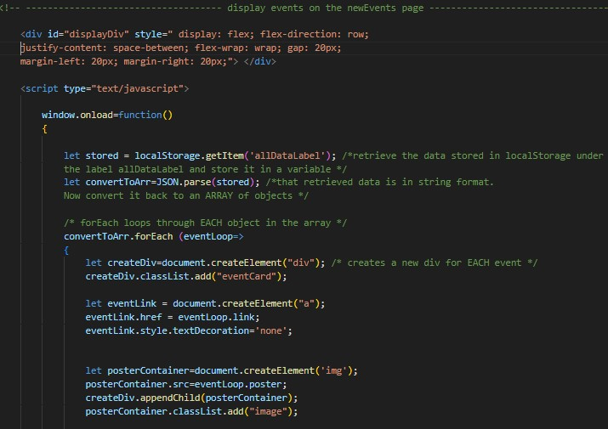
(Figure 1.1 Event Display on Events Page Module)
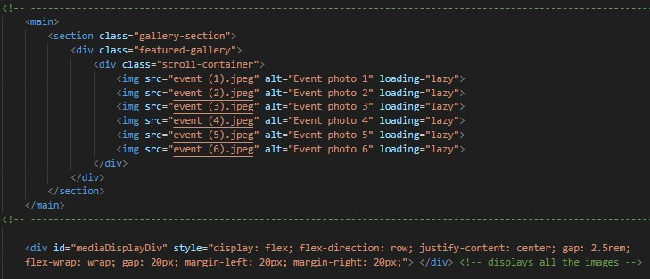
(Figure 1.1 Gallery Display Module)
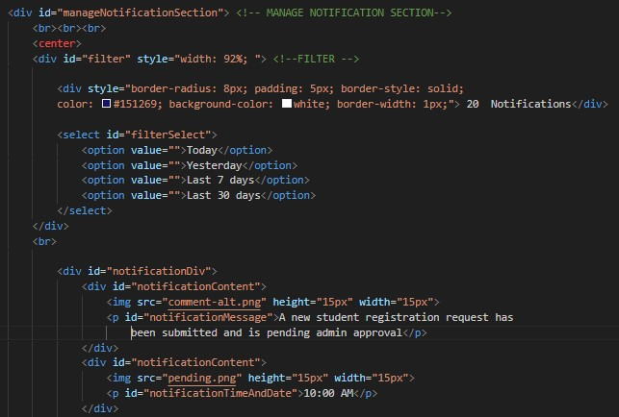
(Figure 1.1 Notification Display Module)

4.6 Testing
- Each button and link was tested for correct navigation.
- Input fields were tested for validation and read-only states.
- Event toggling and payment displays were checked using manual test cases.
- Responsiveness was reviewed on various screen sizes for consistency.

9
Chapter 5
User Manual

5.1 A step-by-step guide on using the front-end system

1. Home Page
- Displays a brief introduction about the event management system and the development team.
- Accessible to all users without login.

2. Events Page
- Lists only upcoming events.
- Each event displays the title, date, description, and an image.
- Logged-in students can book tickets.

3. Gallery Page
- Showcases media from past events (images/videos).
- Users can view event highlights and media.
- Open to all users.

4. Student Panel (Login Required)
After logging in, students can access:
- Dashboard – Displays personalized details.
- Notifications – Shows event-related updates or messages.
- Profile – View and update student information.

5. Admin Panel (Login Required)
Admins can manage the system through:
- Dashboard – Overview of system activity.
- Notifications – Manage updates.
- Profile – Admin details.
- Manage Events – Add, edit, or delete upcoming events.
- Manage Media – Upload past event images/videos.
- Manage Admins – Add or update admin users.
- Manage Students – View or manage student data.
- Payment Records – View and track student payments.

6. User Interactions
- Forms are used for bookings and admin entries.
- Buttons are used for navigation, submissions, and toggling views.

Chapter 6
Conclusion & Further Work

This project successfully delivered a functional and user-friendly event management system tailored for a college environment. The system allows students and the public to view upcoming events, access event media, and provides admin users with a panel to manage events, users, and payments. All objectives set at the beginning were achieved, including the creation of distinct interfaces for students and admins, a gallery for past events, and ticket booking features.
Some challenges included managing layout responsiveness without frameworks and ensuring a clean UI solely using HTML, CSS, and JavaScript. Limited JavaScript knowledge was overcome by consistent learning and practice.
In the future, improvements could include integrating a backend for dynamic content storage, user authentication, and real-time updates. Making the system fully responsive across devices and adding advanced features like search and filter options would further enhance usability.

8

References

[1] W3Schools - https://www.w3schools.com/w3css/defaulT.asp

9
Appendix

Appendix A: Individual’s contribution to the project

Name of student: J.V.A. Kumarasiri

The gallery page of our Event Management System is crafted to present past events in a visually structured and engaging format. This section plays an essential role in displaying media content that captures the essence of college events, student participation, and various activities. The aim is to allow users—including registered students, administrators, and the general public—to browse images and videos of completed events seamlessly.

Designed primarily using HTML and CSS, the gallery layout emphasizes clarity, alignment, and consistent spacing. Each media item is organized neatly, and hover effects are used to enhance interactivity without overwhelming the viewer. Minor JavaScript functions are also implemented to add subtle interactive behavior, keeping the user experience smooth and minimalistic.

Developed using Visual Studio Code, the project helped reinforce practical knowledge in front-end development, especially in crafting responsive designs and styling using CSS. While the gallery does not include any backend, it serves its purpose well by focusing solely on media display.

The interface ensures ease of navigation and a clean aesthetic, inviting all users to revisit the memories of past college events through photos and videos uploaded by the administrators.

Name of student: Sangeetha

My primary responsibility in this project was designing the Home Page as well as the Login and Signup pages for both students and administrators. I used HTML, CSS, and JavaScript to build and style these sections. The home page introduces users to the purpose of the system and provides a brief overview of the development team. I focused on creating a clean, welcoming design with organized sections and user-friendly navigation.

The login and signup pages were built to support both student and admin logins. I implemented separate input validation functions in JavaScript to ensure that users enter proper data formats and receive relevant feedback. Designing these authentication forms helped me better understand form handling, error-checking, and how to enhance user experience through client-side scripting.

One of the main challenges I faced was the JavaScript implementation, especially managing user role detection and simple validation without using backend support. Despite this, I overcame the difficulties by studying additional JavaScript examples, and applying condition-based logic.

This part of the project deepened my understanding of basic front-end logic, form design, layout control using CSS, and interactive scripting with JavaScript. It also gave me valuable insight into how login systems function and how to approach them from a front-end perspective.

Name of student: Krishanthini

I was responsible for designing the Notification Pages for both students and admins in our event management system. These pages were created using HTML and CSS only, without any JavaScript functionality. The goal of the notification section was to provide a clear, visually organized space where users could view important updates related to events, ticket bookings, or admin announcements.

The student and admin notification pages were developed separately to match their respective roles. While both pages share a consistent visual theme for coherence, I made sure to tailor the layout to suit each user type—keeping the student page more event-focused and the admin page more management-oriented.

The major challenge I faced was in designing and structuring the layout effectively. It was important to make sure the notifications were easy to read, well-aligned, and presented in a way that enhances the user experience. Careful attention was given to spacing, text styling, and color schemes to maintain readability and aesthetic appeal.

Through this task, I improved my skills in page layout, CSS styling, and semantic structuring with HTML. This contribution gave me a better grasp of how to communicate important information clearly in a user interface.

Name of student: A.R.F. Rimza

I was responsible for designing the Events Page of our event management system, which showcases all upcoming events in a visually appealing and organized manner. I used HTML and CSS exclusively for this task, as the content was hard-coded for demonstration purposes, focusing purely on the front-end aspect of the system.

The events are displayed in a card-style layout, where each card presents the event poster along with basic details such as the event name and date. This layout not only helps with readability but also adds an aesthetic consistency to the page. When a user clicks on a card, they are taken to a dedicated event detail page that provides more in-depth information, including the full event description, venue, and other relevant details.

Each event detail page includes a "Book Ticket" button. Upon clicking, users are redirected to the payment page, where registered students can fill out a form to complete the booking process. Although the system lacks a backend, the navigation and interaction mimic a real-world flow.

The main challenges I faced were in designing and structuring the layout to ensure clarity, alignment, and user-friendly navigation between pages. Creating a consistent card design that works across various screen sizes required careful CSS styling.

This task allowed me to deepen my understanding of layout design, card-based UI structures, and the importance of clear user flow in web interfaces.

Name of student: F. Mysara

Throughout the project, my primary responsibility was designing and developing both the student panel and the admin panel of the web-based system. The student panel includes the student dashboard, notification system, and student profile section. I ensured these interfaces were user-friendly, responsive, and visually appealing using HTML, CSS, and JavaScript.

The admin panel was more complex and included multiple sections such as the admin dashboard, notifications, profile management, event management, media management, admin and student management, and payment records. I focused on creating a structured layout that allows easy navigation and efficient data handling for administrators.

I developed all interfaces using Visual Studio Code, and handled styling and layout using CSS, while interactions and dynamic behavior were implemented through JavaScript. One of the main challenges I encountered was implementing certain JavaScript functionalities, especially related to form validations, dynamic content display, and local storage handling. To overcome these, I dedicated time to self-learning through w3schools [1] documentation, tutorials, and online forums, which helped me better understand JavaScript's capabilities.

This project improved my understanding of web development and strengthened my ability to work independently. I also learned the importance of writing clean, reusable code and how to troubleshoot and debug more effectively. Overall, this experience enhanced my technical and problem-solving skills significantly.

